## Project for the subject

**INNOVATION & ENTREPRENEURSHIP**

**(UTA025)**

Aakansh Bhandari (101905082)

Geetanshi Gulati (101905076)

Nishita Kadian (101905077)

Pranav Tushar (102085005)

**Group No.: 2 (2EI-4)**

Project Title: **Multidisciplinary Model for Smart Agriculture**

**Course Instructor(s)**

DR. MD Singh

**VENTURE LAB**

**THAPAR INSTITUTE OF ENGINEERING AND TECHNOLOGY, PATIALA**

**Session: July-December,2020**

**(Date of submission: 10/12/2020)**

**CONTENTS**

|  |  |  |
| --- | --- | --- |
|  | ***Title*** | ***Page No*** |
|  | Copyright Notice | 3 |
|  | Certificate | 4 |
|  | Acknowledgements | 5 |
| ***Chapter 1:*** | **Opportunity Analysis** | **6-11** |
| 1.1 | Opportunity Identification | 6 |
| 1.2 | Solution proposed | 6-7 |
| 1.3 | Uniqueness of the solution | 7-8 |
| 1.4 | What problem of the market segment is solved by your solution | 8-9 |
| 1.5 | Identification of users and customers | 9 |
| 1.6 | How will the target users be benefited by the solution | 9-10 |
| 1.7 | How will users discover and adopt their solution | 10 |
| 1.8 | How the market segment will get affected by their solution | 10-11 |
| 1.9 | Filled Opportunity Canvas | 11 |
|  |  |  |
| ***Chapter 2:*** | **Customer Validation Survey** | **12-24** |
| 2.1 | Sample form used for customer survey | 12-13 |
| 2.2 | Size of the customer survey and its documentary proof | 14-15 |
| 2.3 | Results of the survey (question wise) | 15-21 |
| 2.4 | Detailed Analysis of the survey | 21-22 |
| 2.5 | Conclusion of the survey | 23 |
|  | Business Model Canvas | 24 |
|  |  |  |
| ***Chapter 3:*** | **Financial Model** | **25-28** |
| 3.1 | Cost Structure | 25-27 |
| 3.2 | Revenue Structure | 26 |
| 3.3 | Profit & Loss Statement | 26 |
| 3.4 | Cash Flow Statements | 27 |
|  | Cash flow & balance sheet | 28 |
| ***Chapter 4:*** | **Reflections** | **29** |

**COPYRIGHT NOTICE**

©Copyright 2020 by THAPAR INSTITUTE OF ENGINEERING & TECHNOLOGY. All rights reserved. This material may not be duplicated for any profit driven approach.

**CERTIFICATE**

This is to certify that the project report on, **“*MULTIDISCIPLINARY MODEL FOR SMART AGRICULTURE (GROUP NO. 2)*”** being submitted by **Mr. Aakansh Bhandari, Ms. Geetanshi Gulati, Ms. Nishita Kadian and Mr. Pranav Tushar** to the Venture Lab, Thapar Institute of Engineering and Technology, Patiala for the fulfilment of the course requirement of **INNOVATION & ENTREPRENEURSHIP (UTA025)** is a bonafide record of work carried out by us in conformity with the rules and regulations of the institute.

The results presented in this report have not been submitted, in part or full, to any other University or Institute for the award of any degree or diploma.

|  |  |
| --- | --- |
| Dated: December 10, 2020 | Aakansh Bhandari  (101905082)  Geetanshi Gulati  (101905076)  Nishita Kadian  (101905077)    Pranav Tushar  (102085005) |
|  |  |

**ACKNOWLEDGEMENT**

We express our heartiest thanks to all those who have helped us in the preparation and the completion of our technical report on “Multidisciplinary model for smart agriculture”. We wouldn’t have made it this far without the generous support, collaboration, and peer review of the colleagues in the entrepreneurship and innovation, Engineering, and Science faculties and the Dean of Academic Affairs at TIET for providing us with an opportunity for carrying out this technical report.

We are thankful for the able guidance, cooperation and assistance by Mr. Mandeep Singh. We would like to acknowledge his invaluable help and motivation. His experience and diligent quality control helped ensure that this technical report will be a valuable resource for the readers.

We have developed a lot of technical as well as non-technical traits while working remotely as a team.

Also, this report would not have been complete without the support and the endless encouragement from our parents, during tough times, is much appreciated. Lastly, a Big thanks to all the fellow teammates for the stimulating discussions and the sleepless nights without whom this report would not have been possible.

All in all we would like to extend our deepest regards and appreciation to all who have helped us directly or indirectly throughout the course of this report.

**1. OPPORTUNITY ANALYSIS**

**1.1 Opportunity Identification**

The economy of many countries depends on agriculture. To achieve the best quality from this research, it is important to focus on some vital characteristics such as the appropriate amount of electricity as well as water supply and a suitable schedule for irrigation of crops. Farmers are facing problems in meeting these standards, especially those living in poverty.

Our team tried to bring out the most common and daily occurring problems faced by the farmers of India so that we could build a product to address all those issues. So, on surfing the internet, surveying and analysing the current situation of farmers we came to know that following were the problems faced by the farmers of India:

* **No proper farming techniques:** Most of the farmers are not aware of the advancements in this field which can be quite helpful to them while farming. They are still dependent on conventional farming techniques.
* **Soil Degradation:** Farmers usually end up overwatering their fields that leads to both degradation of soil and wastage of water.
* **Disturbance in ecosystem:** Due to the degradation of soil, farmers use synthetic fertilizers to improve quality and quantity of their crops but in turn they end up in creating disturbances in the ecosystem.
* **Unmonitored climatic changes:** Climate change can disrupt food availability, reduce access to food, and affect food quality. For example, projected increases in temperatures, changes in precipitation patterns, changes in extreme weather events, and reductions in water availability may all result reduced agricultural productivity.
* **Power cuts:** In India there are frequent power cuts and non-availability of grid supply. Power is required for water supply through pumps for example.

**1.2 Solution proposed**

On analysing the problems faced by the farmers of India our team came up with the idea of designing and building a multidisciplinary model for smart irrigation. Our model automatically irrigates the fields when needed using the solar power which drives water pumps to pump water from borewell to a tank.

The outlet of the tank is automatically regulated using a controller and moisture sensor to control the rate of the flow of water from the tank to irrigate the fields based on the moisture sensor’s readings. There is a pH sensor as well to determine the deficiency of important nutrients and the pH of the soil according to which the farmers can use fertilizers or pesticides.

This project looks into developing an automated irrigation system. This system will work to minimize the number of workers in a crop field, control and save water and electricity, increase agricultural production using small quantities of water, minimize manual intervention in watering operations with increasing watering speed and preserving plants from pests. All these features make this research sustainable option to be considered to improve the agriculture and irrigation efficiency.

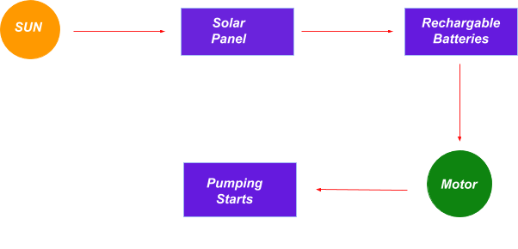

**1.3 Uniqueness of the solution**

Different smart farming models are implemented in various countries. However, a model similar to ours is not implemented anywhere at present.The major components of the model are:

* Solar panel module
* Moisture sensor
* pH sensor
* Automatic irrigation module

Our irrigation model uses solar energy to drive water from a borewell to a tank. Hence there won’t be any fuel cost and power consumption from non-renewable sources.

The outlet valve is regulated automatically using a controller. The controller contains a moisture sensor that regulates the flow and pressure of water, thereby increasing the crop quality and quantity.

This model also has a pH sensor, which tells the amount of different nutrients in the soil, dictating when the farmer should use fertilizers and pesticides and how much to use.

Also, after the initial investment, the model can be used for lifelong. Hence with time, our model is sustainable. All these parameters make our model a unique one.

**1.4 What problem of the market segment is solved by your solution?**

Approximately 60 percent of the Indian population works in the agricultural sector, contributing about 17 percent to India's GDP. The market is already well established so we do not have to create a new market for our model. The only thing we have to worry about are the competitors in the market but to tackle this problem we have a unique selling point which will keep us ahead in the market.

The multidisciplinary model for smart irrigation targets the problems that are being faced by the farmers of India.

* **Helps in energy conservation:** Since our models work on solar energy, it is directly helping in energy conservation.
* **No fuel cost:** We are using renewable energy resources and therefore do not require any fuel such as that produced by burning coal. Thereby reducing the fuel cost.
* **Low maintenance:** Our product doesn’t require a lot of investment in a long run. After an initial investment of setting up, only the maintenance fee would be charged which would be kept minimal.
* **Improved Quality:** Since everything in excess is opposed to nature, overuse of resources also leads to degradation. Our model will use resources in limited amount which in turn not only improve the crop quality but also the soil quality.
* **Sustainable Development:** There is no need for any additional power consumption if one is using our model. Also, after the initial investment, the model can be used for lifelong. Hence with time, our model is sustainable.
* **Modifiability:** The material is chosen based on its ease of modifiability, as its common to come across designs and connections. Also, to be easy to replace or modification required in the future.
* **User friendly:** The reading of the sensors will be shown in the way that it could be understood easily by the farmer. For instance, in our model we are using red led for indicating excess of fertilizer/pesticide in the soil based on the ph sensor’s reading and green to show that more fertilizer/pesticide can be used.

**1.5 Identification of users and customers**

In India, agriculture is the need of most of the Indians livelihood and it is one of the main sources of livelihood. Agriculture also has a major impact on economy of the country. The consumption of water increases day by day that may lead to the problem of water scarcity. Now a days, farmers are struggling hard in the agriculture field and the task of irrigating field is becoming quite

difficult for the farmers due to lack of regularity in their work and negligence because sometimes they switch on the motor and then forget to switch off which may lead to wastage of water.

Our primary focus is on the farmers and all people who are related to agricultural activities.

**1.6 How will the target users be benefited by the solution?**

We aim to provide a sustainable solution for this issue which deals with the everyday problems faced by the farmers in the country. Our solutions help in tackling the problem of irregular supply and over use of pesticides by:

* **No power consumption:** Since the product is made in a way that it can produce its own energy i.e. solar energy no external power would be required. Thus, minimizing the cost and maximizing the profit.
* **Cost Friendly:** Our product doesn’t require a lot of investment in a long run. After an initial investment of setting up, only the maintenance fee would be charged which would be kept minimal.
* **Improved Quantity and Quality:** Everything would be used as required which will save the raw material such as water and pesticides which can be used later. Thereby increasing the produce. Since everything in excess is opposed to nature, overuse of resources also leads to degradation. Our model will use resources in limited amount which in turn not only improve the crop quality but also the soil quality.
* **Adaptive as per requirement:** The material is chosen based on its ease of modifiability, as its common to come across designs and connections. Also, to be easy to replace or modification required in the future.
* **Easy to use:** The reading of the sensors will be shown in the way that it could be understood easily by the farmer. For instance, in our model we are using red led for indicating excess of fertilizer/pesticide in the soil based on the ph sensor’s reading and green to show that more fertilizer/pesticide can be used.

**1.7 How will users discover and adopt their solution?**

We aim to have tie-ups with various governmental/non-governmental institutions who are in direct contact with the farmers. Initiatives like NABARD can help us get in direct contact with the farmers.

Also, not all farmers could afford it.

Government of states where majority of people depend on farming needs to be approached so that people with this simple to use technology could explore different things as well.

Also, campaigns can help in spreading the awareness of the product.

Advertising with the help of banks and other tool companies used in farming can also help.

**1.8 How the market segment will get affected by their solution?**

We feel it is an urgent problem that needs to be addressed as soon as possible as it is leading to soil degradation and disturbance in the ecosystem. If soil degradation continues, soon we will run out of fertile land which will eventually lead to global starvation.

Since the model is purely sustainable, it has no drawbacks and only requires regular examinations.

The model will help in energy conservation. By the help of this model we are conserving not only energy that is produced by burning coal etc, but also we are conserving the manual energy of the farmers which can be utilized to explore different things in turn leading to better income. It helps in

* Reducing fuel cost. Our model operates on almost no fuel.
* No power consumption
* After initial investment, it can be used life long.
* Quality and production of crop will improve.
* Contributes towards Sustainable Development.

**1.9** **Opportunity Canvas**

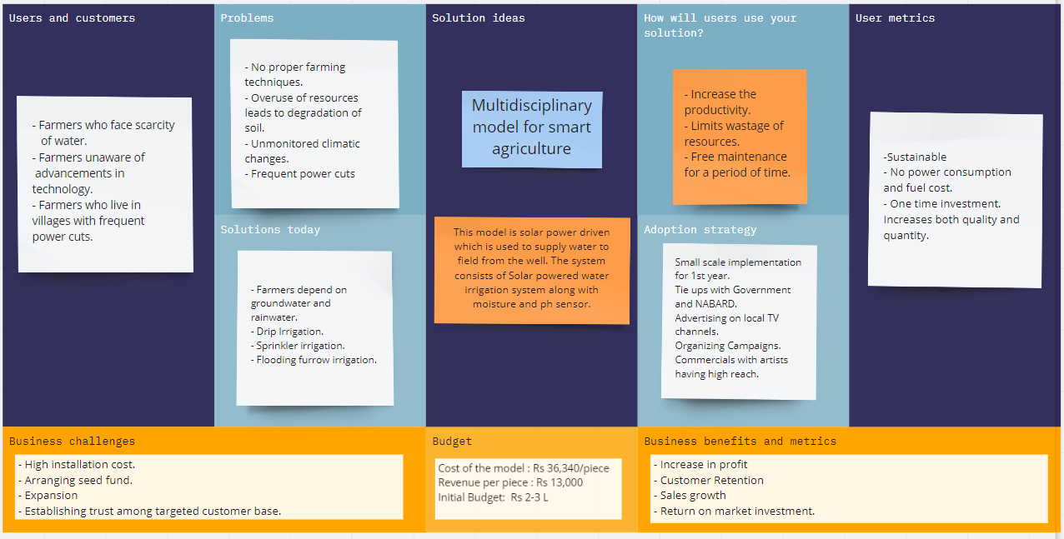

***GROUP 2***

***AAKANSH***

***GEETANSHI***

***NISHITA***

***PRANAV***

**2. CUSTOMER VALIDATION SURVEY**

# **2.1 Sample form used for Customer Survey**

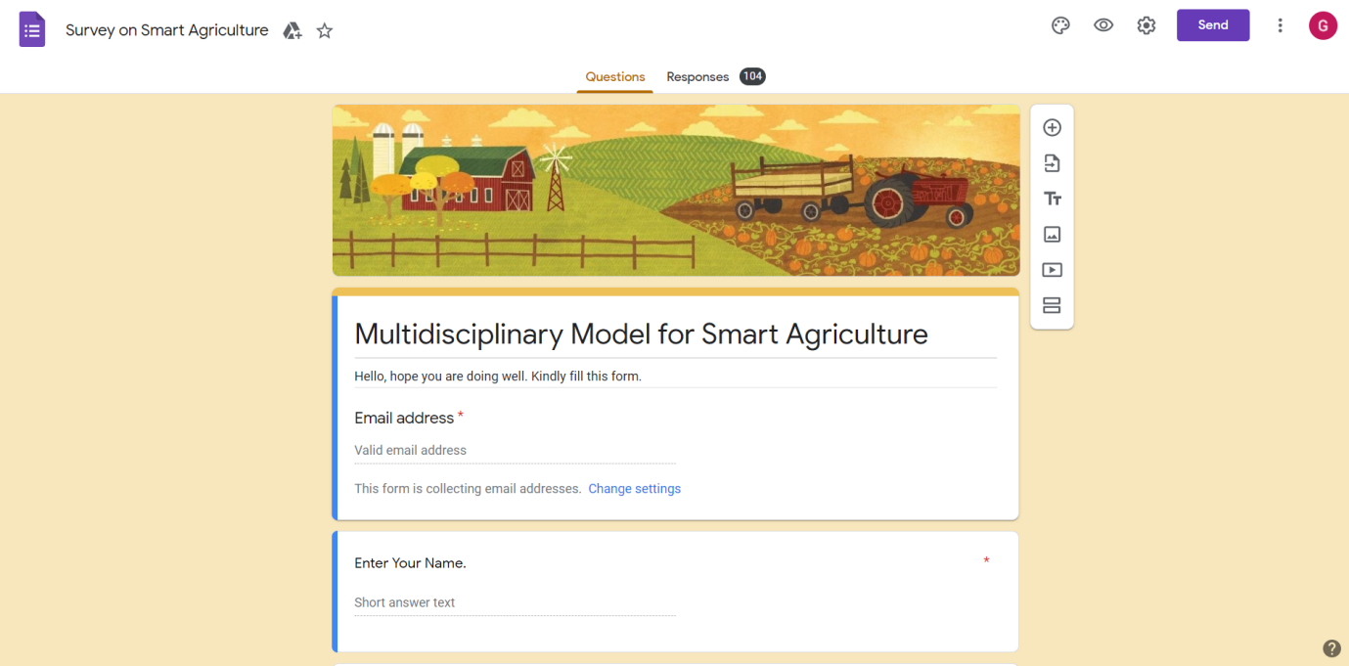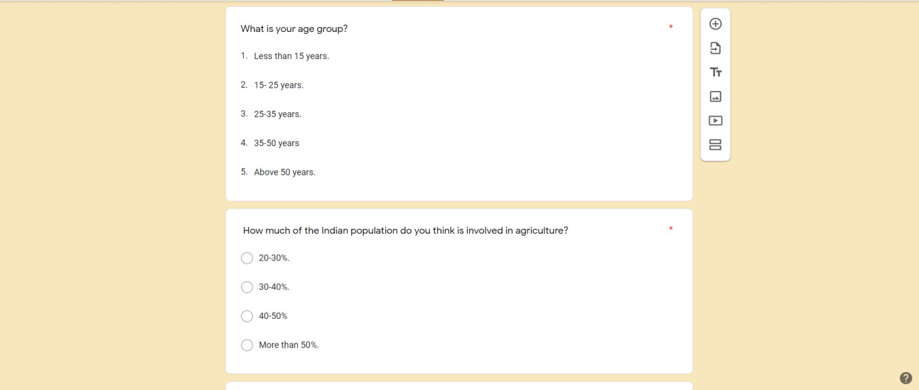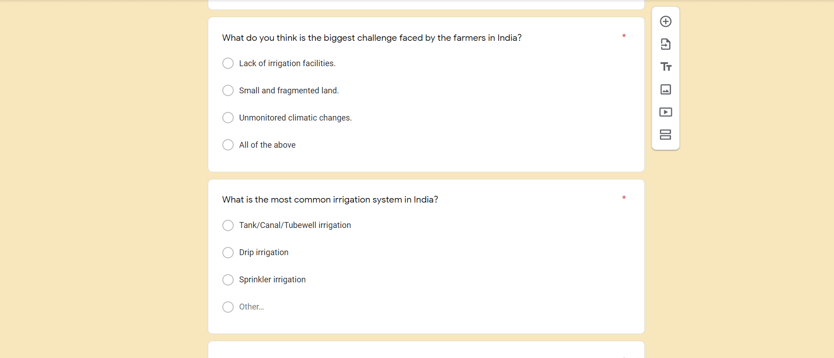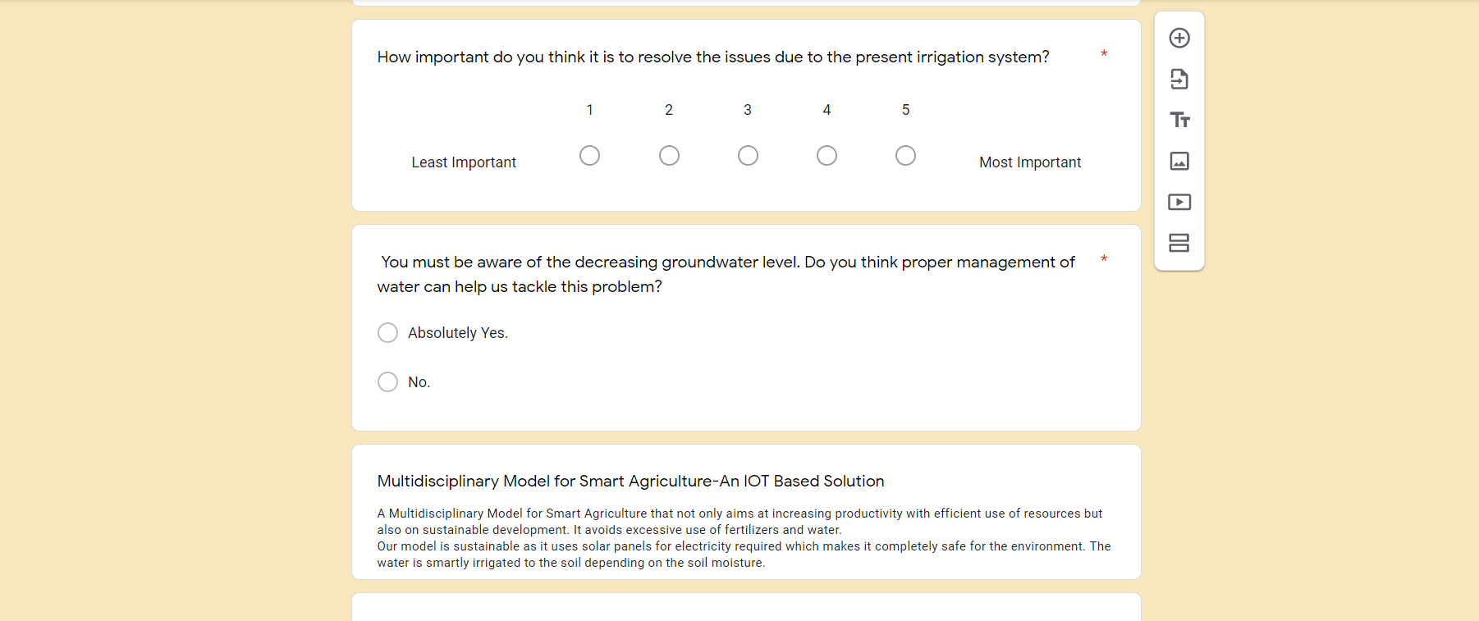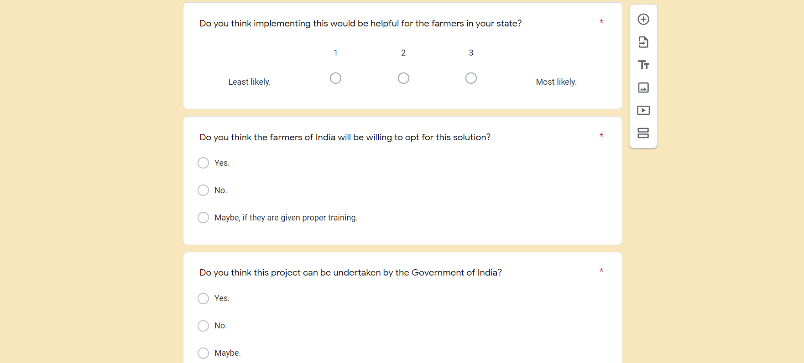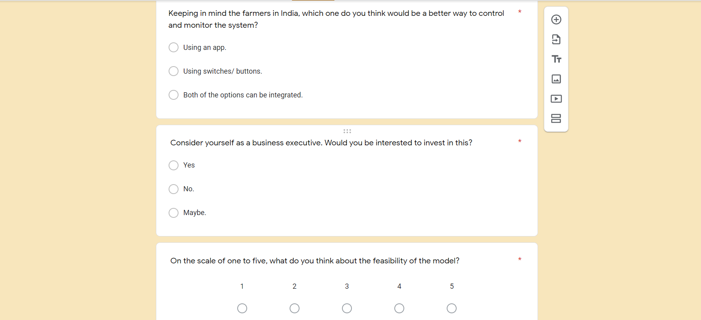

The link to the sample form used for our survey is:- <https://forms.gle/2WhKdHZgjnaW28eR9>

# **2.2 Size of the customer survey and its documentary proof**

Total number of responses = 104 We have successfully collected surveys from about 104 people living in various parts of India. The data collected from google form have been compiled into a google excel file.

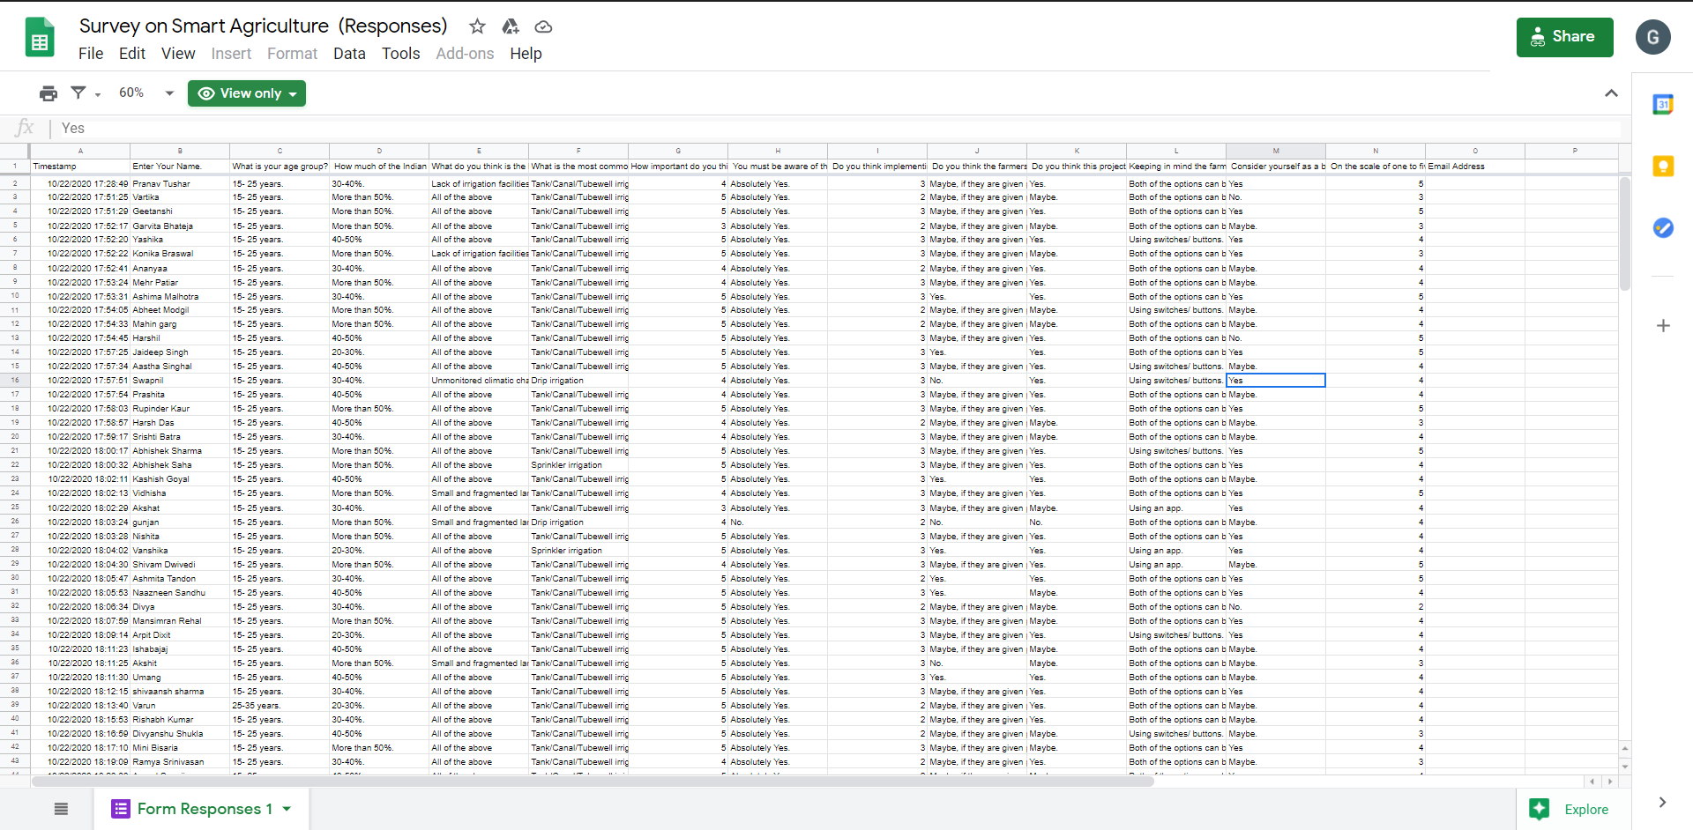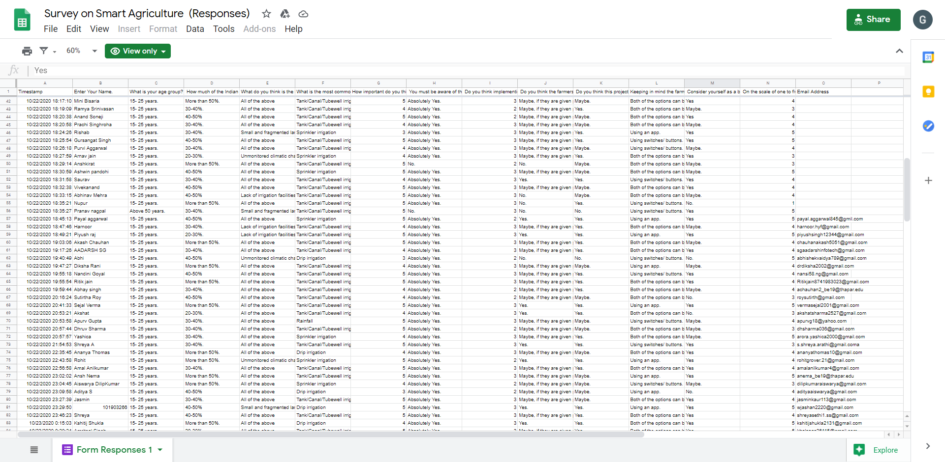

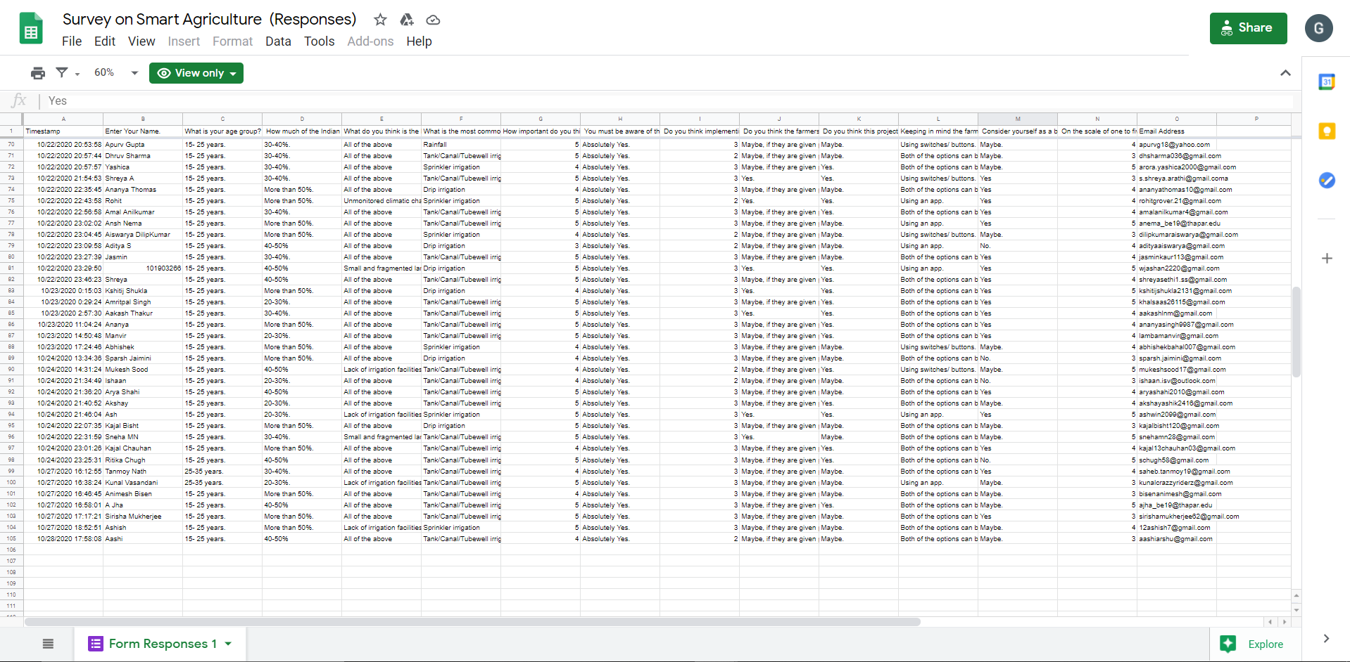

**2.3 Results of the Survey**

The following shows the graphical representation of the feedback given by our respondents.

**Question 1:** What is your age group?

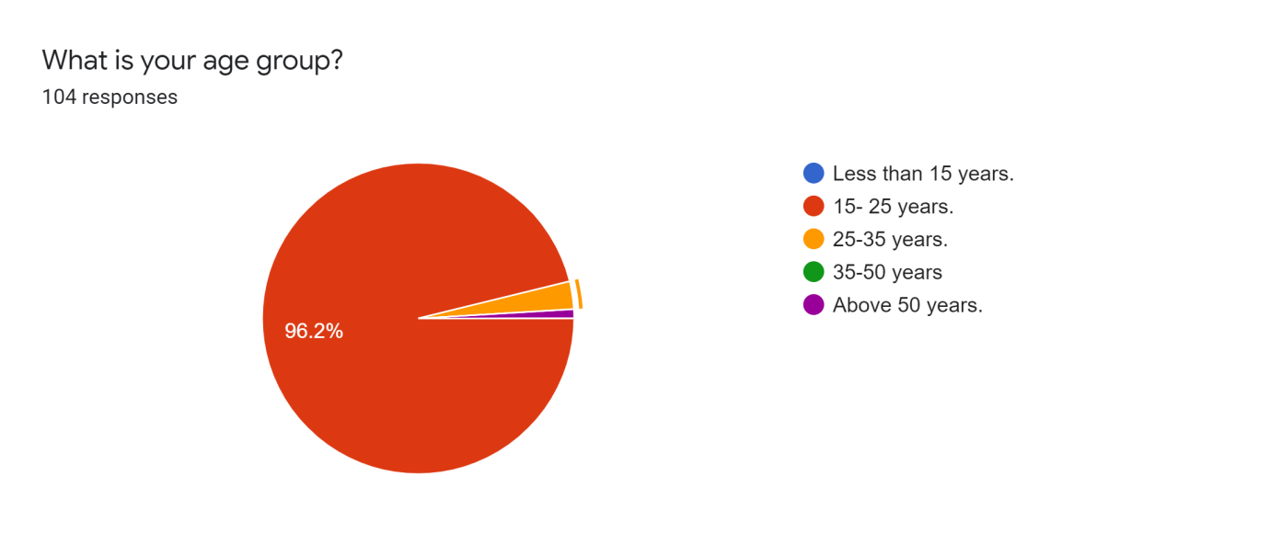

**Analysis:**

* 96.2 percent of the respondents are from the age group of 15-25 years.
* 3 percent of the respondents are between 25-35 age group.

**Interpretation:**

From the above analysis, we understand that most of the respondents are in the age group of 15-25 years and hence their suggestions would definitely have a great impact in the future of India.

**Question 2:** How much of the Indian population do you think is involved in agriculture?

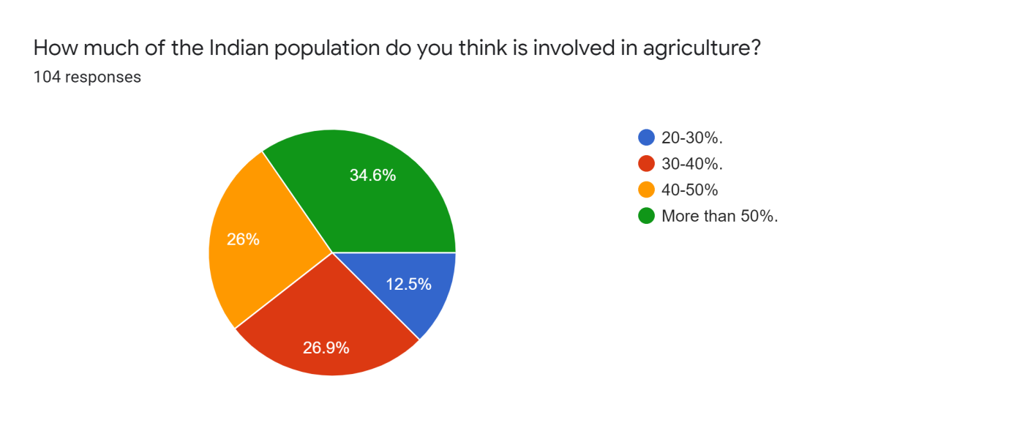

**Analysis:**

* 34.6 percent says more than 50 percent of Indian population is involved in agriculture.
* 26 percent says 40-50 percent of Indian population is involved in agriculture.
* 26.9 percent says 30-40  percent of Indian population is involved in agriculture.

**Interpretation:**

From the above analysis, we understand that the majority of the respondents were right that more than 50 percent of the Indian population are involved in agriculture and a quarter of them were close to it too.

**Question 3:** What do you think is the biggest challenge faced by the farmers in India?

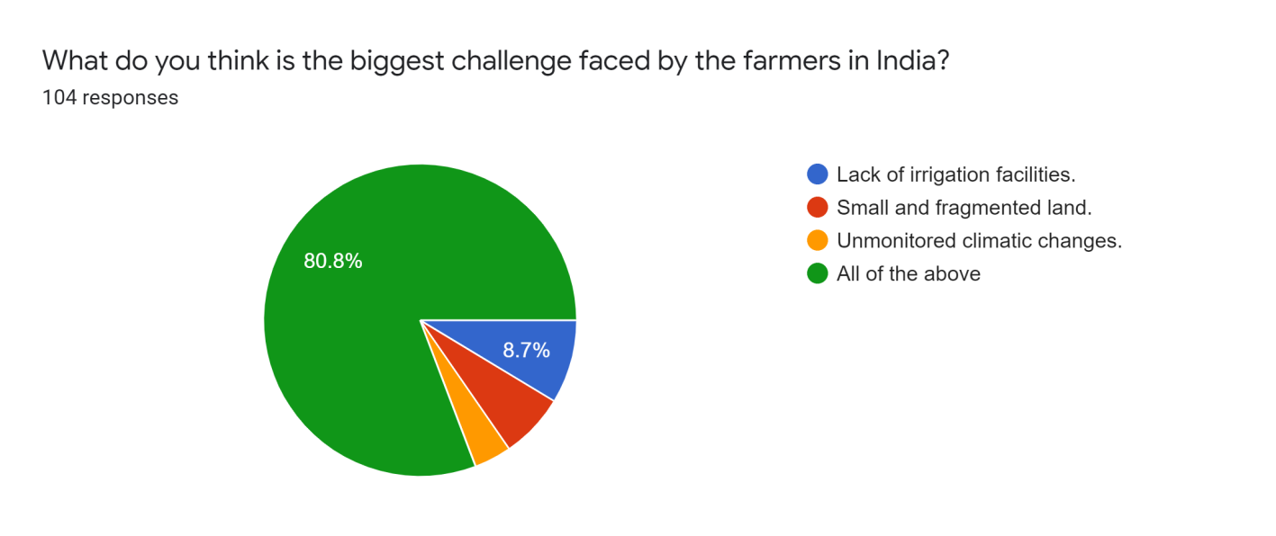

**Analysis:**

* 3.8 percent of the respondents say it is unmonitored climatic changes.
* 6.7 percent of the respondents say it is small and fragmented land.
* 8.7 percent of the respondents say it is the lack of irrigation facilities,
* 80.8 percent of the respondents said all of the above.

**Interpretation:**

From the above analysis, we understand that lack of irrigation facilities, small and fragmented land, and unmonitored climatic changes are a major challenge faced by farmers in India.

**Question 4:** What is the most common irrigation system in India?

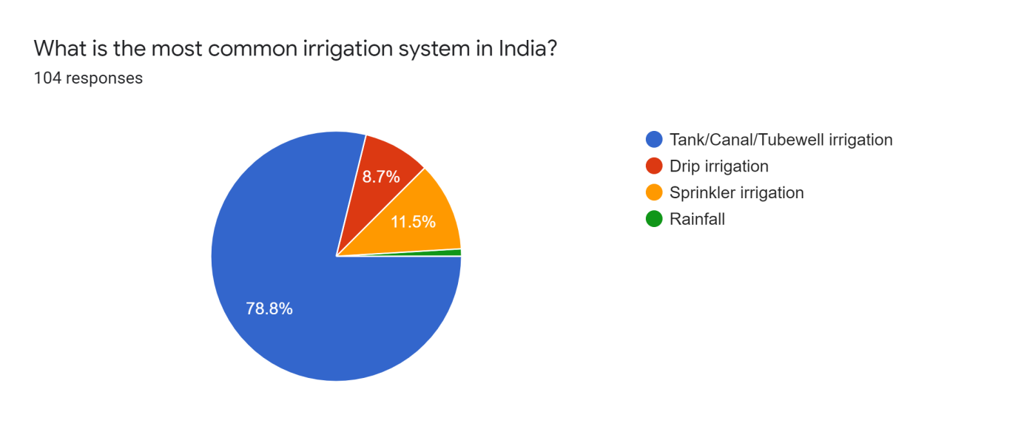

**Analysis:**

* 78.8 percent of the respondents say it is tank or canal or tube well irrigation.
* 11.5 percent of the respondents say it is sprinkler irrigation.
* 8.7 percent of the respondents say it is drip irrigation.
* 1 percent of the respondents say it is rainfall.

**Interpretation:**

From the above analysis, we understand that the most common irrigation system in India is tank or canal or tube well irrigation and the least is rainfall. Rainfall doesn’t occur continuously in a place and hence it has been the lowest preferred.

**Question 5:** How important do you think it is to resolve the issues due to the present

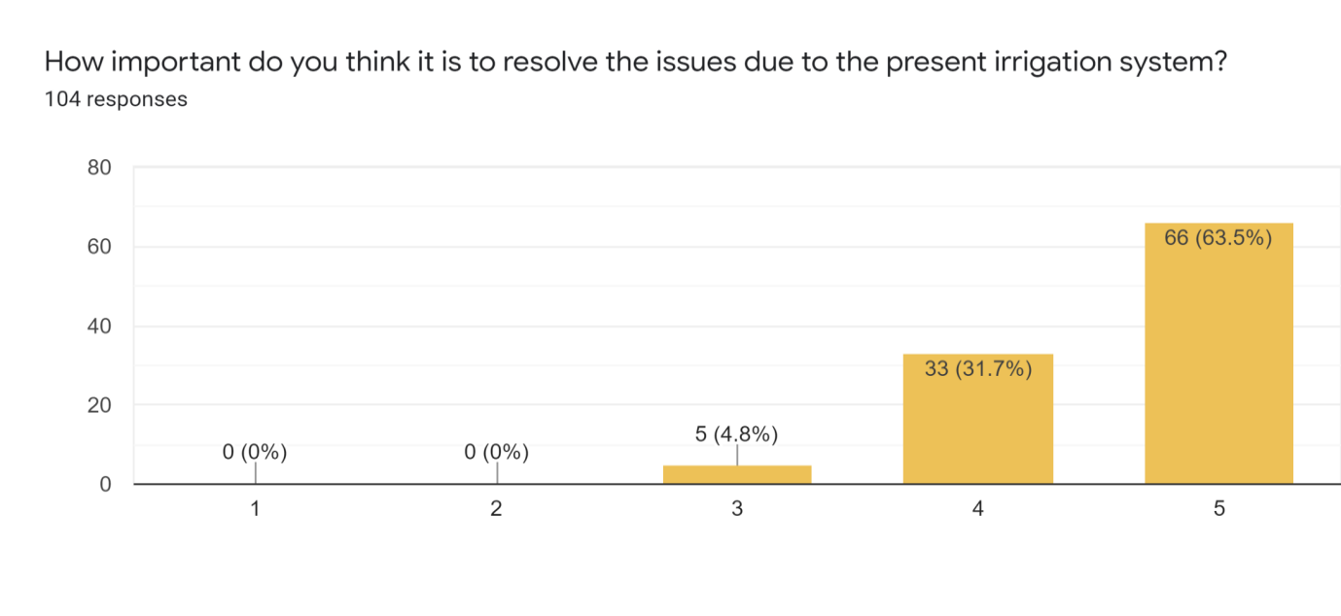                     irrigation system?

**Analysis:**

* 63.5 percent of the respondents say it is very important.
* 31.7 percent of the respondents say it is more important.
* 4.8 percent of the respondents say it is very important.

**Interpretation:**

From the above analysis, we understand 63.5 percent of the respondents find it very important to resolve the issues related to the present irrigation system and the remaining also finds it important. Hence, a better and sustainable solution would have a very big impact in the agricultural sector of India.

**Question 6:** You must be aware of the decreasing groundwater level. Do you think proper management of water can help us tackle this problem?

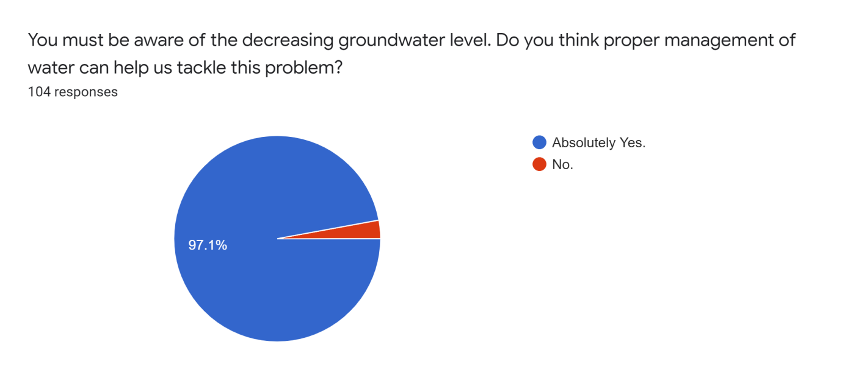

**Analysis:**

* 97.1 percent of the respondents say absolutely yes.
* 2.9 percent of the respondents say no.

**Interpretation:**

From the above analysis, we understand that the majority of the respondents are aware of the decreasing groundwater level and they think a proper management of water is crucial to tackle this issue.

**Question 7:** Do you think implementing this would be helpful for the farmers in your state?

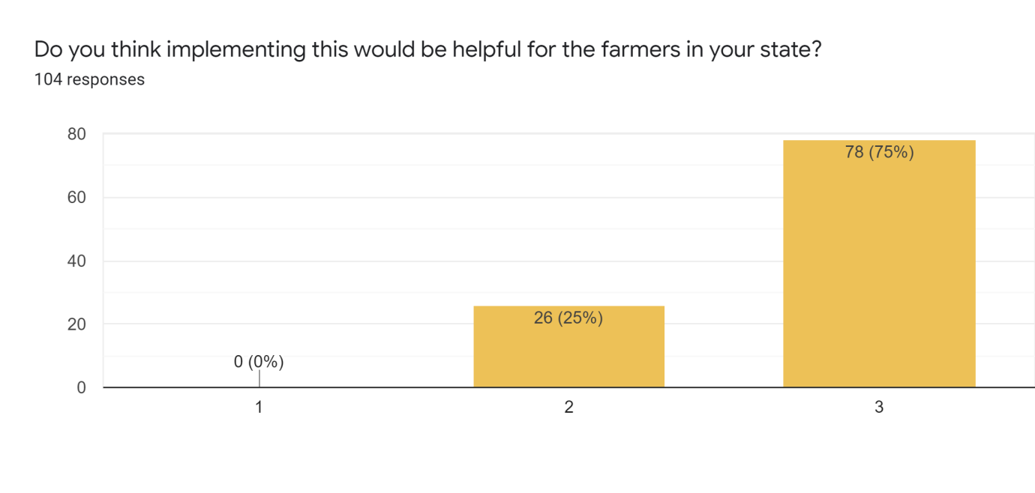**Analysis:**

* 75 percent of the respondents say most likely.
* 25 percent of the respondents say likely.

**Interpretation:**

From the above analysis, all of the respondents think that it’s very likely or likely that it will help farmers in their state. Hence, we understand that the Multidisciplinary model for Smart Agriculture would be helpful for the farmers in India.

**Question 8:** Do you think the farmers of India will be willing to opt for this solution?

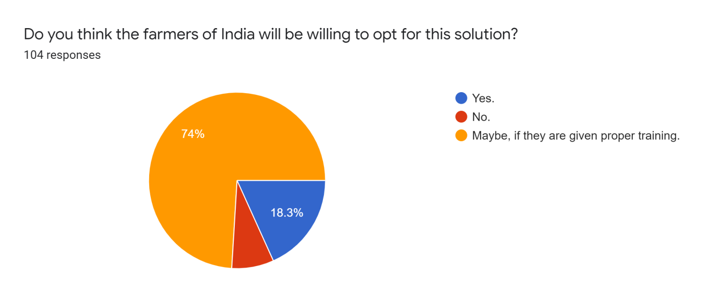

**Analysis:**

* 18.3 percent of the respondents say yes.
* 74 percent of the respondents say maybe if they are given proper training..
* 7.7 percent of the respondents says no

**Interpretation:**

From the above analysis, we understand that the majority of the Indians agree that our solution would be accepted by the Indian farmers if they are given proper training.

**Question 9:** Do you think this project can be undertaken by the Government of India?

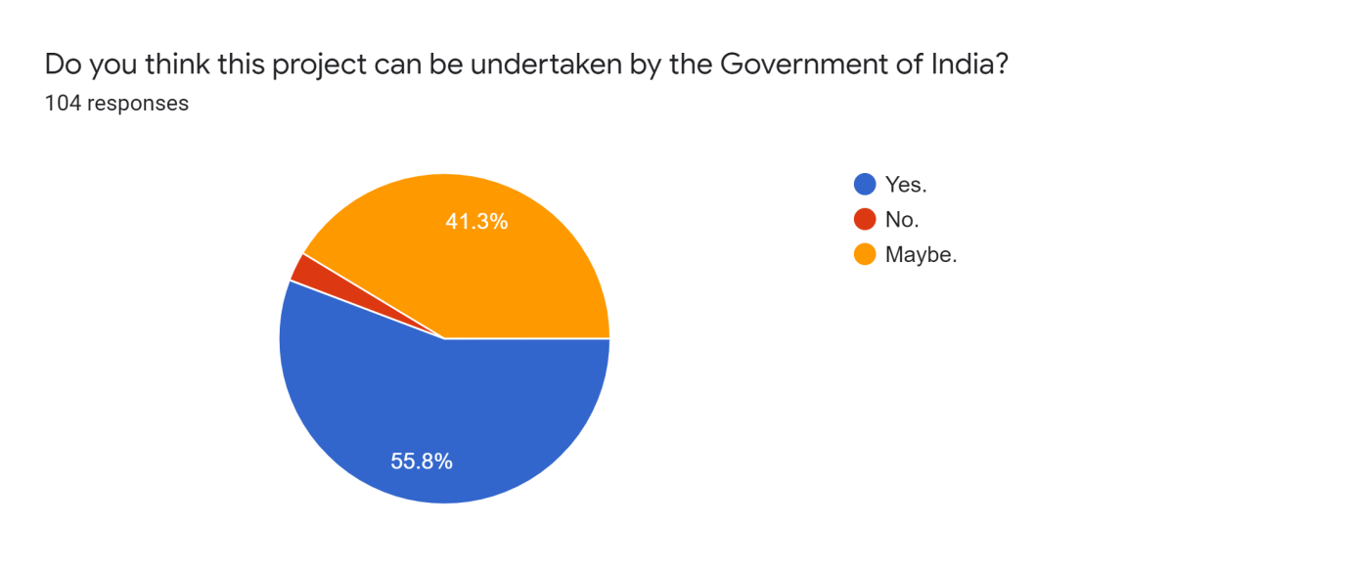

**Analysis:**

* 55.8 percent of the respondents say yes.
* 41.3 percent of the respondents say maybe.
* 2.9  percent of the respondents says no

**Interpretation:**

From the above analysis, we understand that most of the respondents think this project would be undertaken by the Government of India for the betterment and sustainability of the agriculture sector and Indian GDP.

**Question 10:** Keeping in mind the farmers in India,which one do you think would be a better way to control and monitor the system?

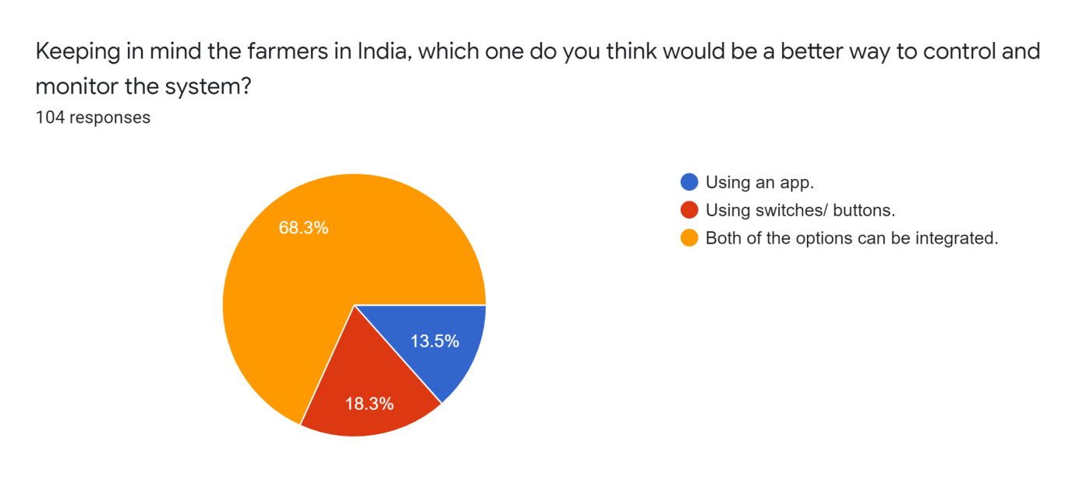

**Analysis:**

* 18.3 percent of the respondents say using switched or buttons.
* 13.5 percent of the respondents say using an app
* 68.3 percent of the respondents say both of the options can be integrated.

**Interpretation:**

From the above analysis, we understand that most of the respondents want to integrate the model with both button or switch feature and app support. By doing so, more farmers would be accepting this solution of sustainability.

**Question 11:** Consider yourself as a business executive. Would you be interested to invest in this?

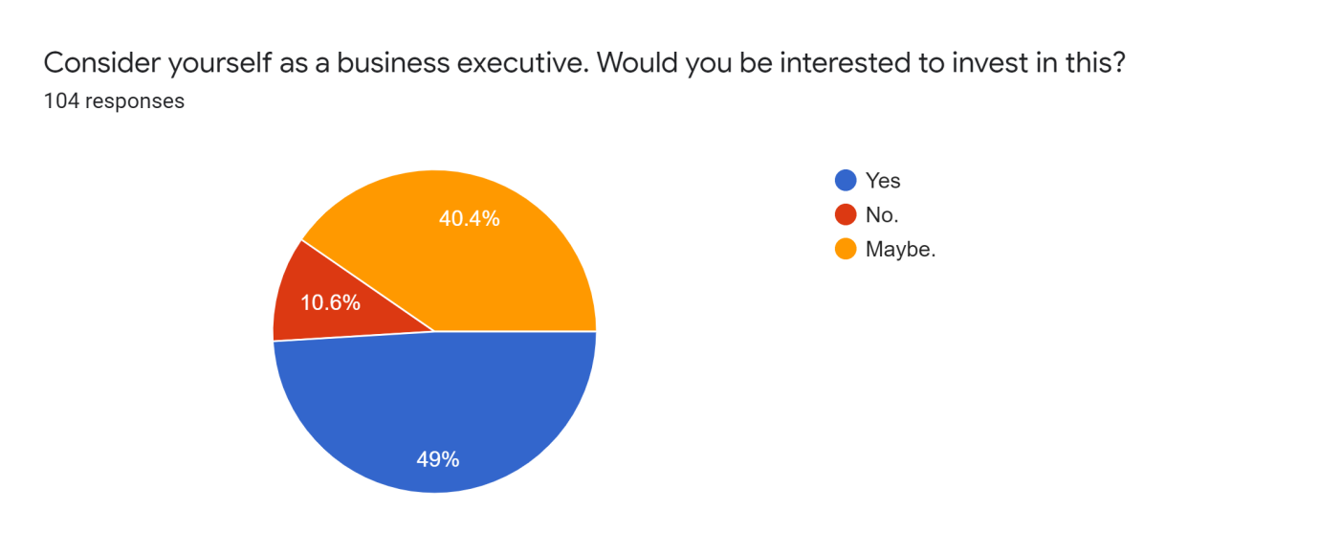**Analysis:**

* 49 percent of the respondents say yes.
* 10.6 percent of the respondents say no.
* 40.4 percent of the respondents says maybe.

**Interpretation:**

From the above analysis, we understand that most of the respondents are willing to invest in our vision of smart agriculture if they are able to. High percentage of positive responses might be because of the sustainability of the model. Also, it is because of the urgent need to tackle the issue of decreasing groundwater.

**Question 12:** On the scale of one to five, what do you think about the feasibility of the

                       model?

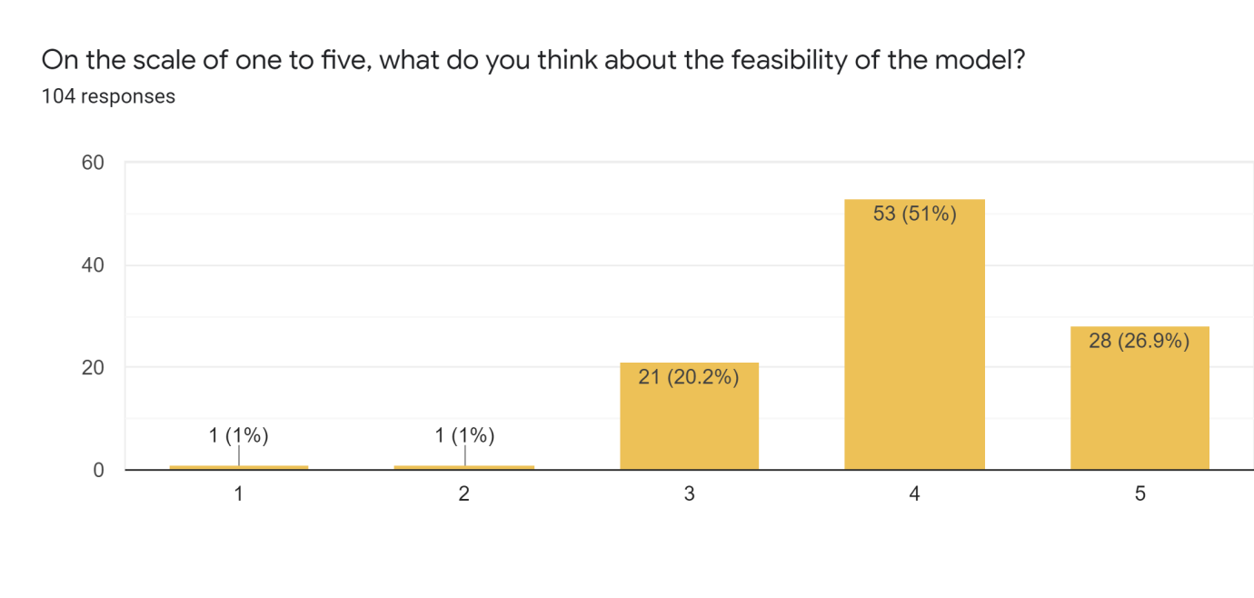

**Analysis:**

* 26.9 percent of the respondents rated 5.
* 51 percent of the respondents rated 4.
* 20.2 percent of the respondents rated 3.
* 2 and 3 were rated by 1 percent of the respondents each.

**Interpretation:**

From the above analysis, we understand that the Multidisciplinary Model for Smart Agriculture is a feasible model.

# **2.4 Detailed analysis of the survey**

For the purpose of this study, primary data was collected using a self-designed questionnaire. The study covered both the students of Thapar University, and our friends from different states of India namely Punjab, Haryana, Rajasthan, Uttar Pradesh, Telangana, Tamil Nadu and Kerala. There are about**104** respondents of which **96.2 percent** of them belong to the age group of 15-25 years and **2.9** **percent** from 25-35 age group and **1** **percent** above 50 years covering students from various streams like engineering, medical and commerce. The survey was carried out from October 2020 to November 2020. Data collection, analysis and interpretation of the results were done during the same period.

The survey covered questions related to agriculture and farmers of India, the  vision and success rate of our model, acceptance and feasibility of our model.

The survey started with a question on “How many of the Indian population do you think is involved in agriculture?” and **34.6** **percent** of them say “more than 50 percent”, **26 percent** say “in between 40 and 50 percent”, **26.9** **percent** says “between 30-40 percent’ and the remaining says “20-30 percent”.

This was followed by a question on “the biggest challenge faced by the farmers in India” which had options: “ Lack of irrigation facilities”, “Small and fragmented land”, “Unmonitored climatic changes” and “ all of the above”. We predicted “All of the above” as the majority and without any surprise, **80.8 percent** of the respondents marked the same.

Next was a question on identifying the common irrigation facilities available for the farmers. The options included “Tank/Canal/Tubewell irrigation”, “Drip irrigation”, “Sprinkler irrigation” and “Rainfall”. A whopping **78.8** **percent** of the respondents marked “Tank/Canal? Tubewell irrigation” followed by “Sprinkler irrigation” and “Drip irrigation” marked by **11.5** **percent** and **8.7** **percent** respectively.

It was followed by a reaction question “How important do you think it is to resolve the issue due to the present irrigation system” which consisted of options “least important”, “less important”, “ important”,” more important” and “most important”. We were surprised to see all of the respondents saying it's important. **63.5** **percent**, **31.7** **percent** , **4.8**  **percent** says it’s “most important”, “more important” and “important” respectively. Hence it was again clear that a better irrigation facility is a must for Indian Farmers.

This was followed by a question whether we could tackle the issues on decreasing groundwater level problems with proper management of water and **97.1** **percent** of the respondents said yes. Data reveals that a proper management is needed as early as possible.

The next questions of the survey are regarding our Multidisciplinary Model for Smart Agriculture. The respondents were given a brief explanation of our model at first itself. At first, we started with asking would our model be helpful for the farmers in their state and **25** **percent** of the respondents marked intermediate and **75** **percent** said “most likely”,

Then the survey had a question on the willingness of the farmers to opt for the solution we are offering. **18** **percent** said “Yes” without any doubt and **74** **percent** of them said “Maybe, if they are given proper training” and **7.7 percent** said “No”.

This was followed by a question “Do you think this project can be undertaken by the Government of India?” About **55.8** **percent** said “Yes”, **41.3** **percent** said “Maybe” and the remaining **2.9** **percent** said “No”.

Then the survey had a question on the control and monitor of the prototype which had options of “Using an app”,”Using switches/buttons” and  “Both of the options can be integrated. **68.3** **percent** of the respondents went with the latter option whereas **13.5 percent** voted for “Using an app” and **18.3 percent** for “Using switches/buttons”.

Then the survey contained a situational question: “Consider yourself as a business executive. Would you be interested to invest in this?” **49 percent** said “Yes” without a further thought and **40.4 percent** said “Maybe” and the rest of them said “No”.

The final question of the survey was on the feasibility of the model.The respondents had to rate the feasibility on a scale of 1-5. About **26.9 percent** rated 5, followed by **51 percent** rated 4, **20.2 percent** rated 3 and ratings 1 and 2 were given **1 percent** each.

# **2.5 Conclusion of the survey**

After going through a variety of questions and the astonishing responses we got from the people surveyed, we have come to the conclusion that it is necessary to have a sustainable agriculture model to tackle the challenges faced by the Indian farmers. Indian farmers cannot depend on rainwater completely and need a better way for water storage. Hence, it is clear that the Multidisciplinary Model for Smart Agriculture is the future and will be a big help for the farmers of India. Through the feedback from people living in different corners of India, we believe that Indian farmers will be opting for the solution if they are given proper training and constant support. Also, based on the feedback, chances are high that the Government of India or various NGOs might undertake the project for the betterment of the agriculture sector in India.

**BUSINESS MODEL CANVAS**

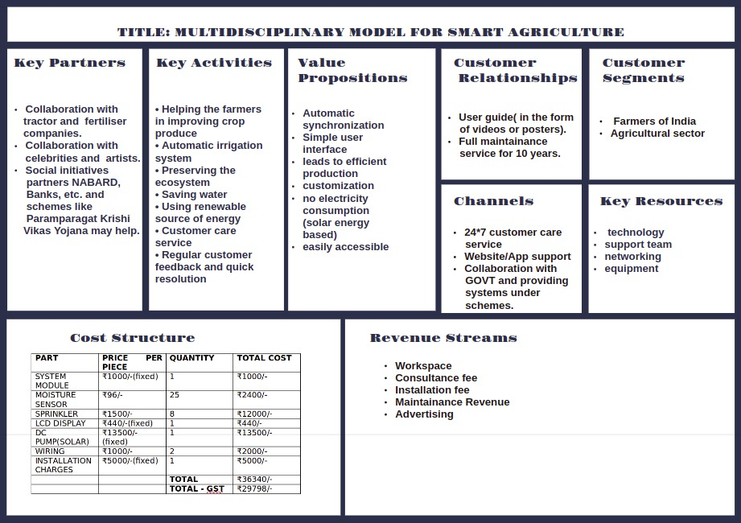

**3. FINANCIAL MODEL**

**3.1 Cost structure**

(this cost structure is for 1 acreland )

|  |  |  |  |
| --- | --- | --- | --- |
| **PART** | **PRICE PER PIECE** | **QUANTITY** | **TOTAL COST** |
| SYSTEM MODULE | ₹1000/-(fixed) | 1 | ₹1000/- |
| MOISTURE SENSOR | ₹96/- | 25 | ₹2400/- |
| SPRINKLER | ₹1500/- | 8 | ₹12000/- |
| LCD DISPLAY | ₹440/-(fixed) | 1 | ₹440/- |
| DC PUMP(SOLAR) | ₹13500/-(fixed) | 1 | ₹13500/- |
| WIRING | ₹1000/- | 2 | ₹2000/- |
| INSTALLATION CHARGES | ₹5000/-(fixed) | 1 | ₹5000/- |
|  |  | **TOTAL** | ₹36340/- |
|  |  | **TOTAL - GST** | ₹29798/- |

**Table 3.1.1** Initial Cost of Manufacturing The Kit

|  |  |
| --- | --- |
| **S.no** | **Fixed costs includes:-** |
| 1 | System module |
| 2 | Display |
| 3 | Installation charges |
| 4 | DC pump |

**Table 3.1.2** Fixed Costs

**(other materials may vary upon the size and structure of land)**

**OVERALL EXPENDITURE:**

|  |  |  |
| --- | --- | --- |
| **ITEM** | **PRICE** | **NEED** |
| Kit price | ₹36,340/-(per piece) | Constant |
| Office rent | ₹7,000/-(per month) | Increases with time |
| Legal fees | ₹15,000/-(need basis) | Increases with time |
| Digital marketing | ₹30,000/-(need basis) | Decreases with time |
| Advertising | ₹10,000/-(need basis) | Decreases with time |
| Design  and development | ₹500/-(per piece) | Increases with time |
|  | **TOTAL COST:-** | ₹62,500/-(Without the price of kit) |

**Table 3.1.3** Cost Structure of Initial Investment

**3.2 Revenue structure**

|  |  |
| --- | --- |
| **Category of revenue** | **Estimated revenue** |
| Selling Price | ₹ 45,000 |
| Expected number of sales per month | 10 Units |
| Total revenue generated (Yearly) | ₹ 54,00,000 |

**Table 3.2.1** Revenue Structure of Yearly Sales

**3.3 Profit Statement**

|  |  |  |
| --- | --- | --- |
| **Commodity** | **Price** | **Profit** |
| Fixed Investments | ₹ 62,500 | nil |
| Kit | ₹ 45,000 | ₹13,660 ((45000-36340)+ 5000) |
| Monthly Earning | ₹4,50,000 | ₹1,36,600 |
| Expected profit per month (of kit) | 10 unit | ₹ 74100 |
| Expected yearly Profit (of kit) | 120 units | ₹ 16,39,200 |
| Overall **monthly** profit | ₹1,36,600-₹62,500 | **₹74,100** |
| Overall **yearly** profit | ₹74,100*12 | **₹8,89,200** |

**Table 3.3.1** Assumptions for Profit and Revenue Generated

**3.4 Cash Flow Statement**

|  |  |  |
| --- | --- | --- |
| **Sr.No** | **Cash Flow Statement** | **Amount** |
|  | **For First Year of Functioning** |  |
| 1 | **Net income from sales of kit** |  |
| 1.a | Amount earned from sales per month | ₹4,50,000 |
| 1.b | Profit earned from sales per month | ₹1,36,600 |
| 1.c | Money Left after monthly expenses | ₹74,100 |
| **2** | **Net income after monthly expenditure** |  |
| 2.a | After deducting monthly cut (-10% for each member) | ₹44,460 |
| 2.b | After deducting -12% of profit for investors | ₹35,568 |
| **3** | **Yearly Expenditure** |  |
| 3.a | Net yearly revenue | ₹54,00,000 |
| 3.b | Net Yearly Profit | ₹8,89,200 |
| 3.c | Investor’s share of Profit | ₹1,06,704 |
| 3.d | Member’s share of profit | ₹3,55,680 |
| **4** | **Total amount left at the end of year** | **₹4,26,816** |

**Table 3.4** Cash Flow Statement

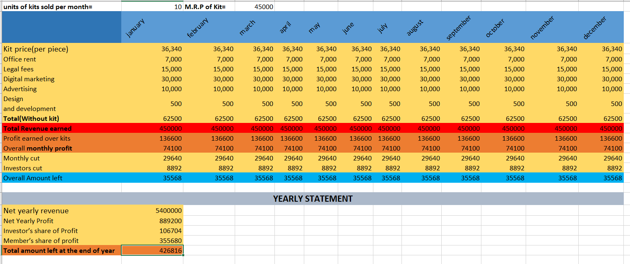

**CASHFLOW**

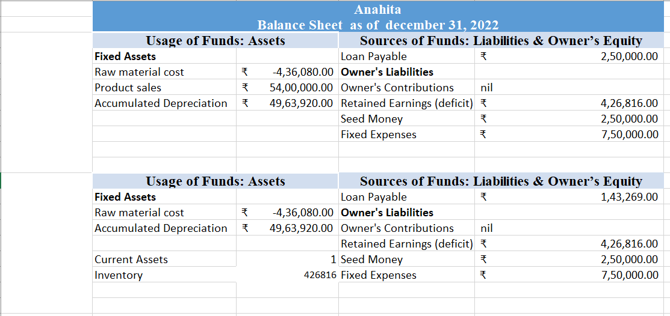

Dec 21

Dec 20

**BALANCE SHEET**

**4. REFLECTIONS**

While working on this project we learnt that it is extremely important to be organised.

Our start-up idea as an entrepreneur helped us in gaining a lot of knowledge about the corporate world. In the beginning, it started as a brainstorm. We had to think about ideas which could benefit us and the community at the same time. While working on our project as a team ,we felt that there is no doubt team theory is relevant in practice. We successfully conducted a survey and researched on the various topics which helped us in making our project better.

Through this project idea we got to learn a lot of skills such as publicity, marketing,

finance handling etc. which are often missing in classroom learning.

Some of the key qualities learnt during this course were:

* Firstly, we understood how to create, discover and evaluate opportunities. A carefully planned project is bound to be far better than an unplanned one. We as a team did a lot of brainstorming to come up with this idea.
* Secondly, for any business to be successful it is important that the team behind it is strong. It demands a lot of accuracy, hard work and patience. Many obstacles came along but we had a strong perseverance and dedication to get through this.
* Through this report we got an idea of the competition in the market and the future prospect.
* Finally, with the guidance and support of our teachers we were able to achieve this model.